**1.Write Code and connections in wokwi for ultrasonic sensor. whatever distance is less than 100 cms send “Alert” to ibm cloud aand display in device recent events.**

**Solution:**

//Pins

const int TRIG_PIN = 7 ;

const int ECHO_PIN = 8;

//Anything over 400 cm (23200 us pulse) is "out of range"

const unsigned int MAX_DIST = 23200;

void setup() {

// The Trigger pin will tell the sensor to range find

Pin Mode(TRIG_PIN, OUTPUT);

digital Write(TRIG_PIN, LOW);

//Set Echo pin as input to measure the duration of

//pulses coming back from the distance sensor

pinMode(ECHO_PIN, INPUT ) ;

// We'll use the serial monitor to view the sensor output

Serial.begin(9600);

}

void loop() {

unsigned long t1;

unsigned long t2;

unsigned long pulse_width;

float cm;

float inches;

// Hold the trigger pin high for at least 10 us

digitalWrite(TRIG_PIN, HIGH);

delayMicroseconds(10);

digitalWrite(TRIG_PIN, LOW);

// Wait for pulse on echo pin

while (digitalRead( ECHO_PIN )==0 );

// Measure how long the echo pin was held high (pulse width)

// Note: the micros() counter will overflow after-70 min

t1= micros ();

while (digitalRead(ECHO_PIN) == 1);

t2= micros ();

pulse_width = t2-t1;

// Calculate distance in centimeters and inches. The constants

//are found in the datasheet, and calculated from the assumed speed

// of sound in air at sea level (- 340m/s)

cm=pulse_Width / 58 ;

inches = pulse_width/148.0;

// Print out results

if (pulse_width >MAX _ DIST ){

Serial.println("Out of range");

} else {

Serial.println("*******************************”);

Serial.print("The Measured Distance in cm: ");

Serial.println(cm);

if( cm < 100 ){

//while(true){

Serial.println(“Alert!!”);

//}

}

Serial.print(“***********************************”);

}

//wait at least 1000ms before next measurement

Delay(1000);

}

**Output:**

**1.If the distance is less than 100 cms ,it alerts.**

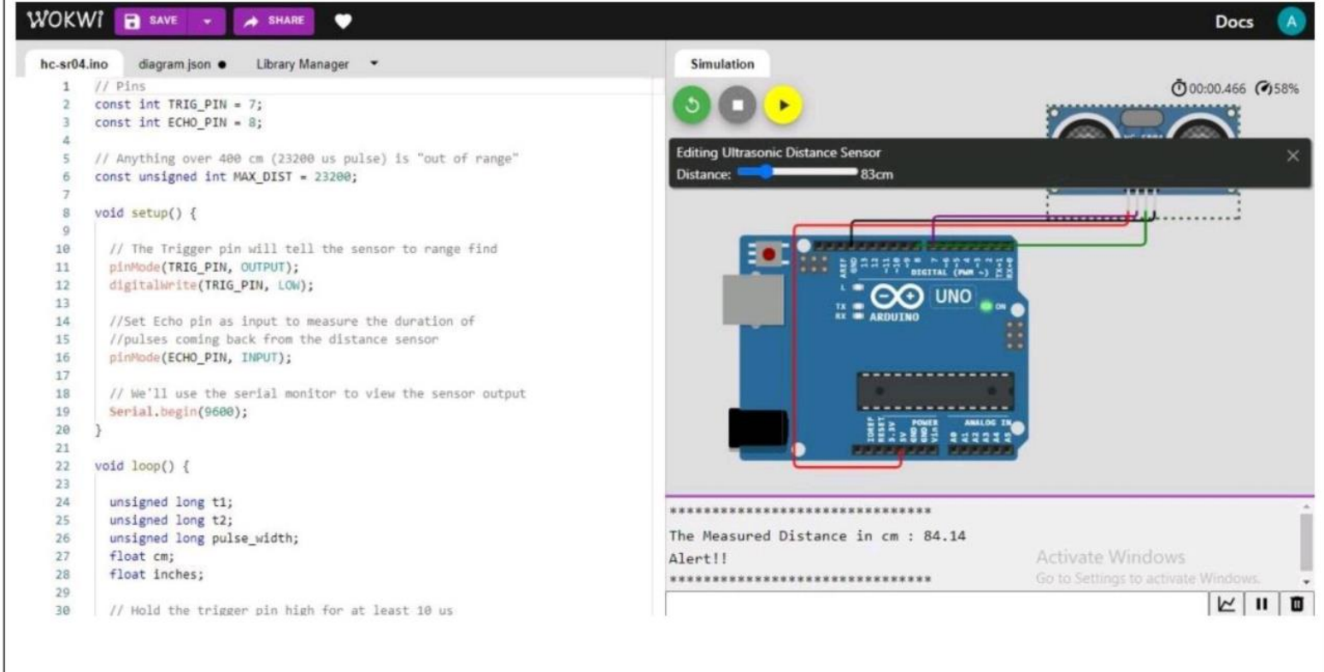

**2.If the distance is more than 100 cms,it won’t alert**

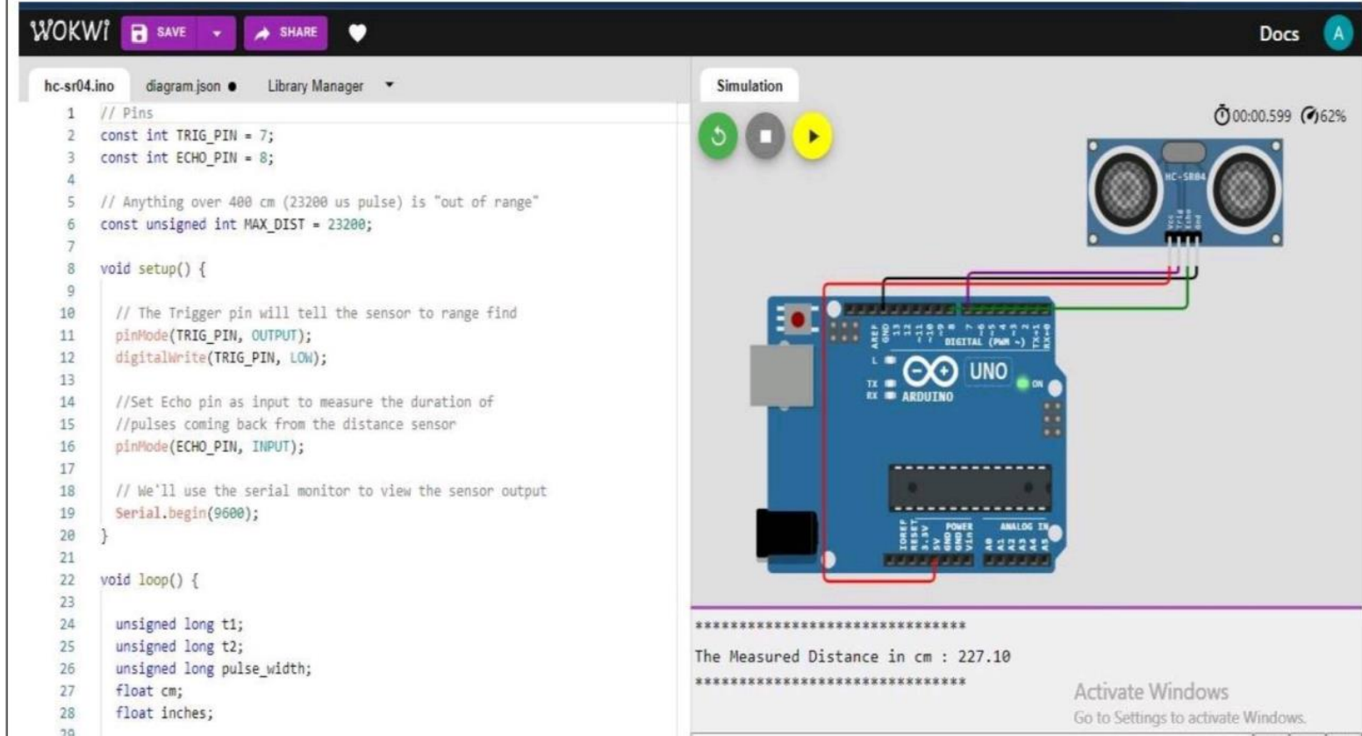

**3.Simulation and code execution**

